THG WAREHOUSES: BOOKING ID PROCESS
When do I need a booking ID?
- Regardless of the shipping carrier, shipment size, or time/length of delivery, when each shipment is ready (before it ships out) you will provide the below charted information in Figure 1/2/3/4 to the appropriate booking ID contacts to request a booking ID.
- This is mandatory for all shipments.
What happens if my PO does not have a booking ID?
- We will not be able to book in any merchandise, delaying the booking in process and vendor payment
- Eventually we will pass on chargebacks for failure to request/label shipments with the booking ID
What does a booking ID do?
- This booking ID allows our warehouse to organize shipments coming in by giving you a delivery timeslot.
How long does it take to get a booking ID?
- Each site will respond within 48 Business Hours with a Booking ID, Date and Time of appointment
What do I do once I get my booking ID?
- Please clearly label your shipment with this booking ID! Failing to do so can create delays in receipts. Please label all outer cartons with the Booking ID.
- Pass the appointment information to your carrier to ensure shipments are expedited. If the courier makes a separate request for a booking ID this can delay the receipt process as well. One Booking ID per shipment!

This process is for our Kentucky, Texas, Chino, and New Jersey Warehouses.

What does a booking ID look like? It will be in this format: XX-XXXXXX-XXX (57 for Kentucky, 58 for New Jersey, 60 for Texas and 64 for Chino)

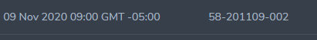

Figure 1. Kentucky (Please copy and paste this chart into your booking ID email).

*Please attach the pack slip for the PO(s) to your booking ID request email!

WAREHOUSE: KENTUCKY
EMAIL: kentuckybookings@thehutgroup.com
PO# | DIV291119271156
Supplier Name: | SRX Natura Bisse
SHIPPING PROVIDER: (ex. Fedex) | Fedex
NUMBER OF CARTONS/PACKAGES/BOXES: | 9
NUMBER OF PALLETS: | N/A
PALLETIZED? (REQUIRED IF OVER 150 LBS/ 12+ Cartons) | N/A
TOTAL UNITS/SKUS SHIPPED | 342
TOTAL WEIGHT | 126 lbs
ESTIMATED ARRIVAL | 12/01 12:00pm

Kentucky: You will email: kentuckybookings@thehutgroup.com. Please attach the pack slip for the associated PO(s) on your booking ID email! The warehouse will then give you a booking ID. Multiple POs can be attached to the same Booking ID, especially if you are palletizing them all together. However, this is not the preference.

Once you have your Booking ID #: PLEASE LABEL THE BOOKING ID ON THE OUTSIDE OF EACH BOX IN YOUR SHIPMENT. If it is palletized, you can label it outside the pallet, but we would prefer to also have it on each box incase anything does get separated. You can label the booking ID with a QR Code or just printed, whatever is easiest for you.

Questions or delayed responses in appointments please contact ryan.cooper@thehutgroup.com and jim.beck@thehutgroup.com

Kentucky Warehouse Address:
1350 Cedar Grove Road
Shepherdsville, KY 40165

Figure 2. New Jersey (Please copy and paste this chart into your booking ID email).

*Please attach the pack slip for the PO(s) to your booking ID email!

WAREHOUSE: NEW JERSEY
WHO TO EMAIL:
NJDC.BOOKINGID@gmail.com
NJDC.BOOKINGID2@gmail.com
nerineFA@gmail.com
fergusonops@gmail.com
PO# | DIV291119271156
Supplier Name: | SRX Natura Bisse
SHIPPING PROVIDER: (ex. Fedex) | Fedex
NUMBER OF CARTONS/PACKAGES/BOXES: | 9
NUMBER OF PALLETS: | N/A
PALLETIZED? (REQUIRED IF OVER 150 LBS/ 12+ Cartons) | N/A
TOTAL UNITS/SKUS SHIPPED | 342
TOTAL WEIGHT | 126 lbs
ESTIMATED ARRIVAL | 12/01 12:00pm

New Jersey: You will email: NJDC.BOOKINGID@gmail.com;NJDC.BOOKINGID2@gmail.com;nerineFA@gmail.com;fergusonops@gmail.com. Please attach the pack slip for the associated PO(s) on your booking ID email! The warehouse will then give you a booking ID. Multiple POs can be attached to the same Booking ID, especially if you are palletizing them all together. However, this is not the preference.

Once you have your Booking ID #: PLEASE LABEL THE BOOKING ID ON THE OUTSIDE OF EACH BOX IN YOUR SHIPMENT. If it is palletized, you can label it outside the pallet, but we would prefer to also have it on each box incase anything does get separated. You can label the booking ID with a QR Code or just printed, whatever is easiest for you.

Questions or delayed responses in appointments please contact ryan.cooper@thehutgroup.com

New Jersey Warehouse Address:
6 Greek Ln
Edison, New Jersey 08817
Figure 3. Texas (Please copy and paste this chart into your booking ID email).

*Please attach the pack slip for the PO(s) to your booking ID email!

WAREHOUSE: Texas
WHO TO EMAIL: THGBookings@sekologistics.com
PO# | DIV291119271156
Supplier Name: | SRX Natura Bisse
SHIPPING PROVIDER: (ex. Fedex) | Fedex
NUMBER OF CARTONS/PACKAGES/BOXES: | 9
NUMBER OF PALLETS: | N/A
PALLETIZED? (REQUIRED IF OVER 150 LBS/ 12+ Cartons) | N/A
TOTAL UNITS/SKUS SHIPPED | 342
TOTAL WEIGHT | 126 lbs
ESTIMATED ARRIVAL | 12/01 12:00pm

Texas: You will email: THGBookings@sekologistics.com .THG bookings will then give you a booking ID. Please attach the pack slip for the associated PO(s) on your booking ID email! The warehouse will then give you a booking ID. Multiple POs can be attached to the same Booking ID, especially if you are palletizing them all together. However, this is not the preference.

Once you have your Booking ID #: PLEASE LABEL THE BOOKING ID ON THE OUTSIDE OF EACH BOX IN YOUR SHIPMENT. If it is palletized, you can label it outside the pallet, but we would prefer to also have it on each box incase anything does get separated. You can label the booking ID with a QR Code or just printed, whatever is easiest for you.

Questions or delayed responses in appointments please contact ryan.cooper@thehutgroup.com

Texas Warehouse Address:
8551 Esters Blvd
Ste 100
Irving, TX 75063

Figure 4. Chino (Please copy and paste this chart into your booking ID email).

*Please attach the pack slip for the PO(s) to your booking ID email!

WAREHOUSE: CHINO
WHO TO EMAIL: michael.monge@sekologistics.com, juan.perez@sekologistics.com, john.alvarado@sekologistics.com
PO# | DIV291119271156
Supplier Name: | SRX Natura Bisse
SHIPPING PROVIDER: (ex. Fedex) | Fedex
NUMBER OF CARTONS/PACKAGES/BOXES: | 9
NUMBER OF PALLETS: | N/A
PALLETIZED? (REQUIRED IF OVER 150 LBS/ 12+ Cartons) | N/A
TOTAL UNITS/SKUS SHIPPED | 342
TOTAL WEIGHT | 126 lbs
ESTIMATED ARRIVAL | 12/01 12:00pm

Chino: You will email: michael.monge@sekologistics.com; juan.perez@sekologistics.com;john.alvarado@sekologistics.com. Please attach the pack slip for the associated PO(s) on your booking ID email! The warehouse will then give you a booking ID. Multiple POs can be attached to the same Booking ID, especially if you are palletizing them all together. However, this is not the preference.

Once you have your Booking ID #: PLEASE LABEL THE BOOKING ID ON THE OUTSIDE OF EACH BOX IN YOUR SHIPMENT. If it is palletized, you can label it outside the pallet, but we would prefer to also have it on each box incase anything does get separated. You can label the booking ID with a QR Code or just printed, whatever is easiest for you.

Questions or delayed responses in appointments please contact ryan.cooper@thehutgroup.com

Chino Warehouse Address:
Seko Logistics Omni
15702 Cypress Ave
Chino, CA 91708

PROCURE EMAILS:

Booking ID’s will be issued via automated email from our Procure system with a QR code attachment. Packages should be labeled with both booking ID and QR code. Please check all folders of your mailbox (including junk mail) for a booking ID email from service@t.thg.com. If you cannot find it, please reach out to your planner for assistance. Please see below for an example email issuing a booking ID and example QR code attachment.
EXAMPLE EMAIL:

From: service@t.thg.com <service@t.thg.com>
Sent: Friday, October 9, 2020 10:31 AM
To: Kentucky Bookings <kentuckybookings@thehutgroup.com>
Subject: THG/Procure: Delivery booking creation

THG/Procure

Delivery booking confirmation

Dear Supplier / Carrier,
Thank you for your booking request. Your delivery has now been scheduled and the Booking Reference Number is 57-201023-000
Your reserved delivery slot is at Friday, October 23, 2020 05:00 into our Warehouse address below:
THG Kentucky - THG Kentucky
1350 Cedar Grove Road
Shepherdsville
40165
KY
United States
We do have a full supplier manual containing our delivery requirements, however, please find below some key points worth checking before attempting to deliver into our warehouse.
Please note the list below is not a replacement for reading our Supplier Manual but is intended to support you with some quick and easy checks.
Warehouse specific instructions:
- All your cartons/pallets should be labelled with your Booking Reference Number as above.
- All PO’s being delivered must be quoted at time of booking request.
- Please ensure that your driver/carrier has the booking reference as they will be required to quote this at the gatehouse to gain entry to the site.
- If delivering on pallets, these must be Euro’s (1200mm x 800mm).
- Please note that the maximum height for a single pallet of stock is 1.8metres (including the pallet).
- Please note that the maximum weight for a single pallet of stock is 1000kg (including the pallet)
- All items on the delivery must be barcoded.
- No outer cartons can weigh more than 25kg, i.e. one man lift
- No delivery will be reworked by The Hut Group. All Deliveries must comply with the requirements of our Supplier Manual otherwise you will be asked to uplift and rework it
- We cannot accept extra-long trailers >16.5m due to turning circle restrictions onsite.
On the day of delivery if you know that your driver is running late or is unlikely to show please contact us as soon as possible on kentuckybookings@thehutgroup.com, jim.beck@thehutgroup.com, beckja@thehutgroup.com, kayla.russell@thehutgroup.com, chassidy.stout@thehutgroup.com, angela.inabnit@thehutgroup.com, CourierResponses@thehutgroup.com informing us of your booking reference and anticipated time of arrival.
We will then attempt to rebook you to a date/time more suitable to your new arrival time.
If you do not inform us in advance you will be asked to wait until our next available slot on arrival. Please note priority will be given to vehicles that turn up on time.
Regards,
Goods Inwards Team

©2020 - The Hut Group

EXAMPLE BELOW OF OUTER CARTON LABELING:

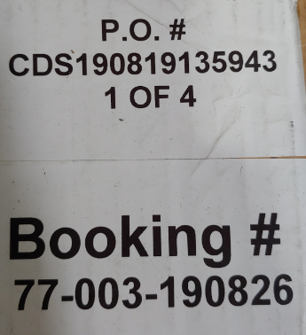
Image Example of what should be on the outside of your box

- Requirements:
  - Booking ID – barcoded (preferred)
  - PO #


Master Shipping Carton
- Requirements:
  - Booking ID – barcoded (preferred)
  - PO#
  - Number of boxes
  - If mixed carton indication that it is mixed
- Good to have:
  - SKUs in box with Qty and barcode
- Perfect Example Label 1 box
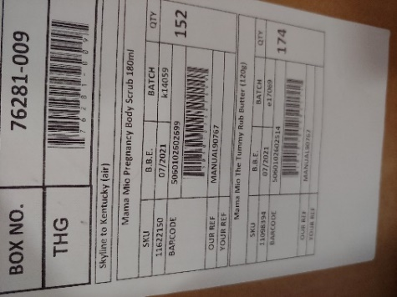

- Near Perfect Example multiple boxes (Booking ID should be barcoded)
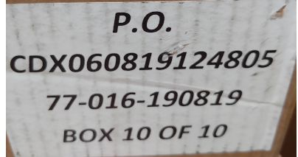
- Another close example. (Needs Booking ID)
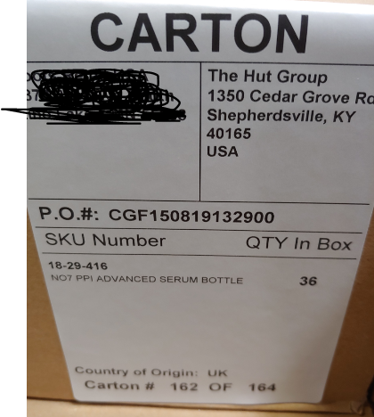
Inner Carton
- Requirements:
  - If mixed carton indication that it is mixed
  - SKUs in box with Qty with barcoded information
- Good to have:
  - Date & lot code information barcoded
- Prefect Inner carton example
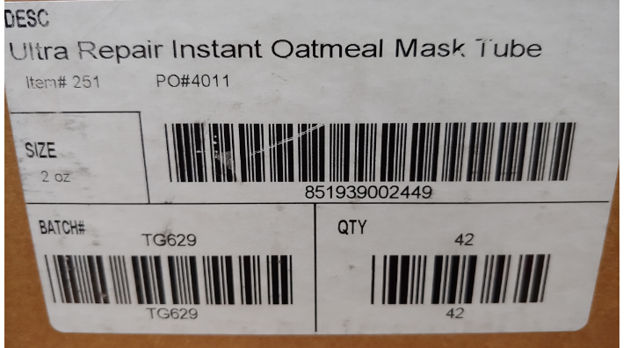
- Clear indication of a mixed carton and what is inside of it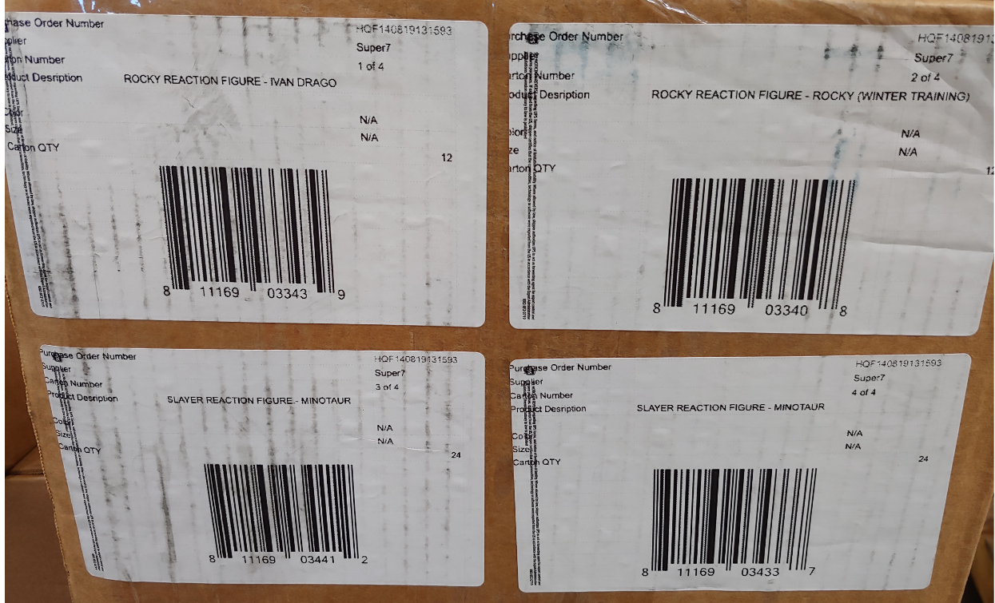
- Single item in carton example:
